Graduate Student Checklist
Masters in Speech-Language Pathology

_____ CSD Academic and Clinical Education Manual
- This manual is online and available through the CSD website.
- Graduate students are responsible for knowing and understanding all content included in this manual.
- This manual is minimally updated annually. You need to use and review this throughout your SLP program continually.

______ Create an ELIS Account
- You will need to have an ELIS account before you complete your content test for the Professional Educator License.
- This system will track you test scores, degree(s), and endorsement for the Illinois State Board of Education.
- This site provides detailed instructions (and helpful videos) on creating an account.
  - You will need your social security number, address, phone number, and email to do this.
- You need to create this account by the end of the finals week of your first fall term.

______ Degree Option Requirement
- Each student will be required to select one of the following degree options by the end of the final week of the first spring semester:
  - Comprehensive Exams
  - Independent Study
  - Master’s Thesis
- See the department manual for specific guidelines and requirements for each option (link above)
- When you have determined your FINAL selection, please submit this form before the date listed above: https://forms.illinoisstate.edu/forms/graduate_degree_option_selection

_____ Dates and Deadlines of the Graduate School
- The Graduate School provides dates and deadlines that should be referred to throughout your graduate program.
- The graduating term should be used to find appropriate dates and deadlines.

_____Content Test for IL Educator License
- You must have created an ELIS account BEFORE you take this test.
  - See directions above if you have not done this.
- This test is a requirement for the Illinois Educator License
- Students must register and pass the non-teaching speech-language pathology content test (test code 232) prior to licensure.
  - We recommend that you complete this exam by the end of the fall term of the second year.
- Choose ISU as a recipient of your scores so your tests can be verified for your milestones/licensure processing.
  - ISU code is 018.
- See detailed information with links to study resources below:
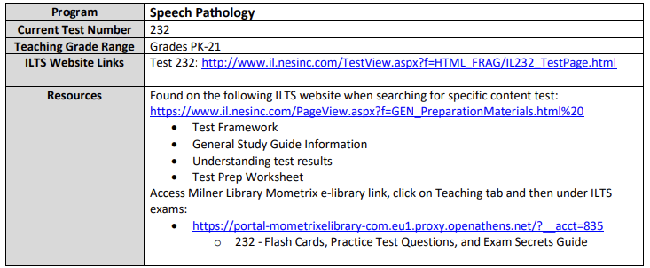

_____ Master’s Degree Audit
During your last semester of academic coursework (likely fall term of the 2nd year), you will complete and submit your master’s degree Audit to Mrs. Verticchio.
- Mrs. Verticchio will send you a template to complete to initiate this process.
- It will be a 3-page document.
  - On page 1, you will need to type in your personal information at the top of the page (Last Name, First Name, UID)
  - On pages 2-3, type in your Name, UID, Address, Email, and Phone numbers, and enter the grade you earned for each course listed.
    - For grades not yet awarded, leave them blank.
- Save this document as your last nameMDA (ex. VerticchioMDA) and email it to Mrs. Verticchio at hrfritz@ilstu.edu

_____ Application for Graduation AND Commencement Participation
During the fall term of your 2nd year, you will complete your application to graduate and participate in commencement.
- Under Submission Requirements, you can complete the application for graduation (and pay the fee) using the Online Form.

_____ Intent to File for Certification
- Follow these steps to initiate your process for the Illinois Educator License.
  - Select Graduate/Advanced Licensure
  - Complete the Intent for Licensure form.
  - Complete all other steps outlined on this web tab for Graduate/Advanced Licensure

_____Praxis: National Exam in Speech-Language Pathology
- Students should register and complete this exam during their last semester of academic coursework, which is typically in the Fall term of the 2nd year.
- Register for this exam through ETS/Praxis
  - Test scores should be sent to the following locations:
    - ISU (code RA0073)
    - ASHA (code R5031) (required for ASHA certification)
    - Illinois Department of Financial and Professional Regulation (IDFPR) (code R7219) (required to work in Illinois)
- To be certified in speech-language pathology, students complete the Praxis Subject Assessment in Speech-Language Pathology (Test Code 5331).
- ETS/Praxis study materials can be purchased.

_____ During your last semester of the program (Spring term of 2nd year), you will meet on-campus with the Director of Clinical Experiences-Speech-Language Pathology. All the following paperwork components will be addressed at that time:
- ASHA Certification Application
- Illinois Professional Educator License
- Illinois License in Speech-Language Pathology--Temporary and Permanent
- Transcript Requests
- Documentation to complete during your CF.

Director of Advisement:
Heidi Verticchio
hrfritz@ilstu.edu
309.438.3266

Director of Clinical Education – Speech-Language Pathology:
Cara Boester
clboest@ilstu.edu
309.438.2318

